**BLUETOOTH RADIO LAYER**

The rangeof Bluetooth depends upon the these key factors, they are as follows

1. Radio Spectrum.

2. Transmit Power.

3. Receiver Sensitivity.

4. Antenna Gain and

5. Path loss.­

**Radio Spectrum :-**

The radio spectrum is a part of the Electromagnetic(EM) Spectrum with frequencies that range from 30 Hz to 300 Ghz. EM waves in this frequency range are called as radio waves. EM Spectrum is show in below following Figure.

The lower the frequency or lower the energy, the longer in range. For lower Frequency the data rate is also lower which are inversly proptional. Depending on application the range and data rate hasto be seleceted.

Frequency ( ) = range ( ) = data rate ( )

At present new emerged wireless technologies are using radio environment for communication. The Great benefit of using radio technology is that the transmission is done in all directions. However , Bluetooth was not first attempt at manuipulating for wireless communication, Infrared had been used as an alternative to data cables. Bluetooth overcame one major limitation of Infrared it is Line of sight. For example the daily use of tv remote which we are using has to be pointed towards tv for chaning channels. Due to radio technology bluetooth can be used for short range wireless communications. Bluetooth operates in the unlicensed radio frequency band 2.4 Ghz. This frequency band is also used by some other wireless Systems which uses IEEE 802.11. The Bluetooth technology avoids interference and fading by using the low power transmitters in combination with the frequency hopping spread spectrum (FHSS) technique and it basic rate achives 1MBs by Time Division Duplexing (TDD) method. The nominal hop rate is 1600 hops per second, thus the Radio Frequency occupancy is very less. Bluetooth technology uses ISM band at frequency 2.4 Ghz. The frequency range is 2400 – 2483.5 Mhz.

F = 2402 + k [Mhz], where k = 0, ... , 78.

79 RF channels are avaliable in this frequency band. Each RF channel bandwith is 1 Mhz. In order to comply with out-of-band regulations, it has two Gaurd bands, Lower gaurd(2400 - 2402) and Upper Gaurd bands(2480 – 2483.5), Which helps in avoding interference between other licensed bands.

**Transmit Power :-**

Bluetooth or radio waves behave like any other wave, such as sound waves. The disctance that a wave travels dependes on how loud one shouts and the obstacles. If we want to communicate through a little bit longer then we need burn more energy for amplifying the sound in the sence we need to shout louder, thus louder the voice travels little bit more. For shouting we need energy, similary Bluetooth is power dependent. It we want to increase the range of Bluetooth transmission then we need to change the power. There are three power classes in Bluetooth to increase range of communication.

|  |  |  |  |
| --- | --- | --- | --- |
| **Power classs** | **Max Power level** | **Operating Range** | **Examples** |
| Class 1 | 100 mW (20 dBm) | Up to 100m (328 feet) | USB adapters, Access point. |
| Class 2 | 2.5 mW (4 dBm) | Up to 10m (33 feet) | Mobile devices, Headsets. |
| Class 3 | 1 mW (0 dBm) | Up to 1m (3 feet) | Mouse, Keyboards. |

Power control is used to keep the signals within the limit so that device works efficiently without interfering with the other neighbour bluetooth devices. These Power control algorithm is designed between master and slave devices using link management Protocol. There is a change in bluetooth operating ranges indoor environmennts due to obstacles between the two end devices, such as walls , glass that attenuate signals. Thus the range is influenced by transmitter strength, receiver sensitivity, and obstructions in the device’s proximity. Bluetooth SIG said that these technology can be used at a range of more than 3,281 feet ~ 1 kilometer. We can also avoid interfering with other systems by sending out very week signals of about 100 milliwats. Using low power limits the range of a bluetooth device ranges to 652.2 feet ~ 200 meters.

**Note** :- We can also increase the Operating range by repeaters. For example , a 33 foot range device connected to a 1000 foot repeater allows the device to a 1000 foot range. Radio spectrum stretches from 30 Hz to 300 Ghz. The lower the frequency, the longer the range.

**Receiver Sensitivity :-**

Receiver Sensitivity is defined as the measure of how well an receiver can hear and understand. In general terms the lowest energy when a speaker audio is able to hear by the receiver. In Bluetooth terminology , the lowest power at which the receiver can detect a radio signal and of low error rate in data. The ability of a receiver to identify and amplify signals at the receivers input is called Receiver Sensitivity. It is expressed in dbm. The receiver Sensitivity leverl tells us the weakest signal that a receiver will be able to identify and process.It can be improved by reducing the noise level and bandwidth of the receiver. Bluetooth technology specifies that devics must achive a minimum receiver sensitivity of -70 dBm to -82 dBm. However, Bluetooth typically achieve much higher receiver sensitivity levels of -95 dbm or much more better.

**Antenna Gain :-**

Antenna Gain is defined as the power transmitted by an antenna in a specific direction as compared to an **isotropic antenna** (antenna which transmit power equally in all directions). Gain describes how strong a signal an antenna can send out or receive in a specific direction. Antenna Gain is defined as a unitless measure that combines antenna’s directivity and electrical efficiency.

**Antenna gain** (G)= **electrical efficiency** (E.antenna) **x directivity** (D).

where efficiency of an antenna is the total radiated power P0  divided by the input power.

E.antenna = P0 / pin

where directivity is the measure of the concentraction of an antenna’s radation pattern in a particular direction and efficiency accounts for the losses of the antenna due to manufacturing faults, surface coating irregularities.

In a transmitting antenna , the gain describes how accurate an antenna converts input power into radio waves which is headed in a specific direction. In the receiving antenna , the gain describes how accurate antenna converts radio waves which are receiving at specified direction into electrical power.

**Path Loss :-**

Path Loss is also called as path attenuation. Path Loss is defined as the loss of power of an RF signal travelling through space. It is expressed in decibals (dB). There are so many effects for the path loss scuch as free-space loss, refraction, diffraction, reflection, aperture_medium coupling loss and absorption. Path loss is also influenced by following factors :-

1. The Distance Between transmitting and receiving antennas.

2. Line of sight clearancebetween the receiving and transmitting antennas.

3. Antenna height.

4. Terrain contours.

5. Environment like urban, rural, vegetation and foliage.

6. propagation medium such as dry or moist air.

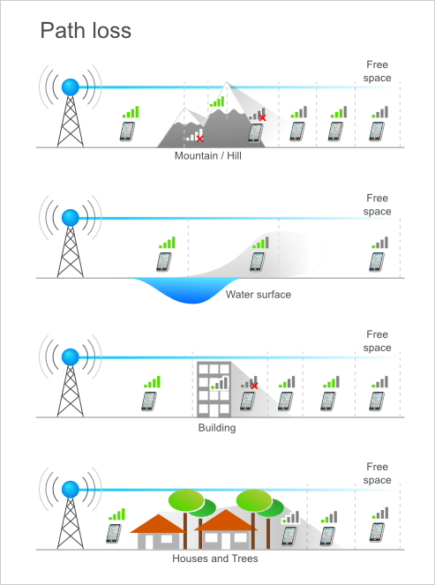 **FIG** :- Path Loss In free space

**Bluetooth range Estimator** :-

https://www.bluetooth.com/learn-about-bluetooth/bluetooth-technology/range/